**GAME DEV HEROES COMMUNITY**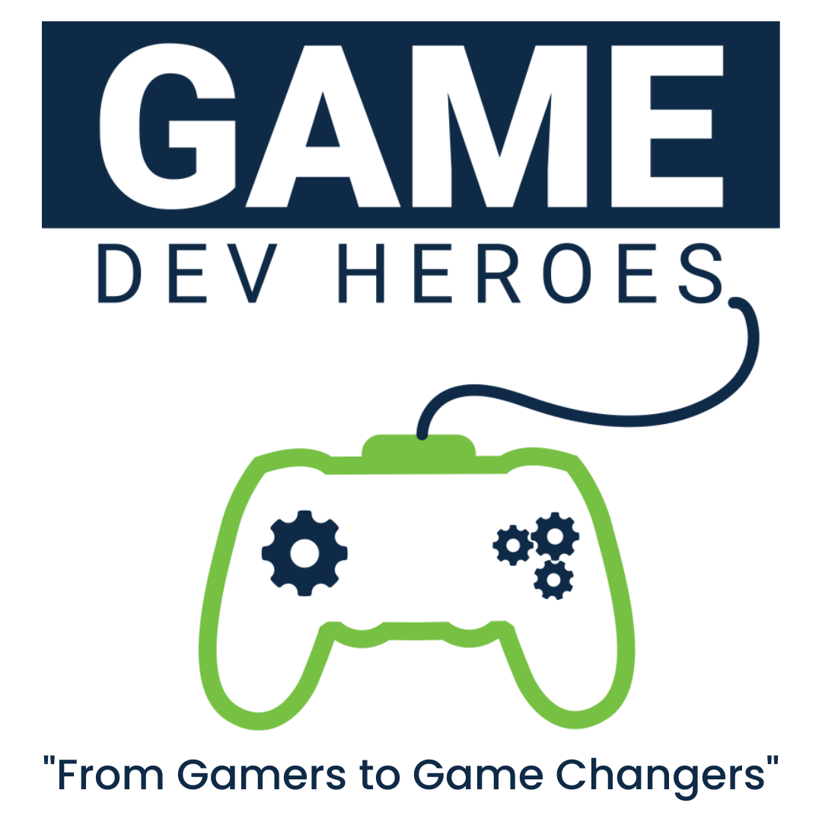

**Introduction to Game Dev Heroes Community**

**Game Dev Heroes Community** is part of the Herald DevCorps Communities at Herald College Kathmandu, which was established on **August 6, 2019**. In this community, you will find people who create, play, research, and develop games related to gaming. Our aim is to develop our own games by sharing gaming knowledge and ideas among ourselves. Our goal is to educate ourselves and others to the best of our ability. The community focuses on investigating and learning about the structure, steps, and abilities required for a career in game creation. Students can join this community if they are inquisitive about games and their platforms, interested in the gaming industry, or both.

**Game Dev Heroes Community Tagline**

"From Gamers to Game Changers"

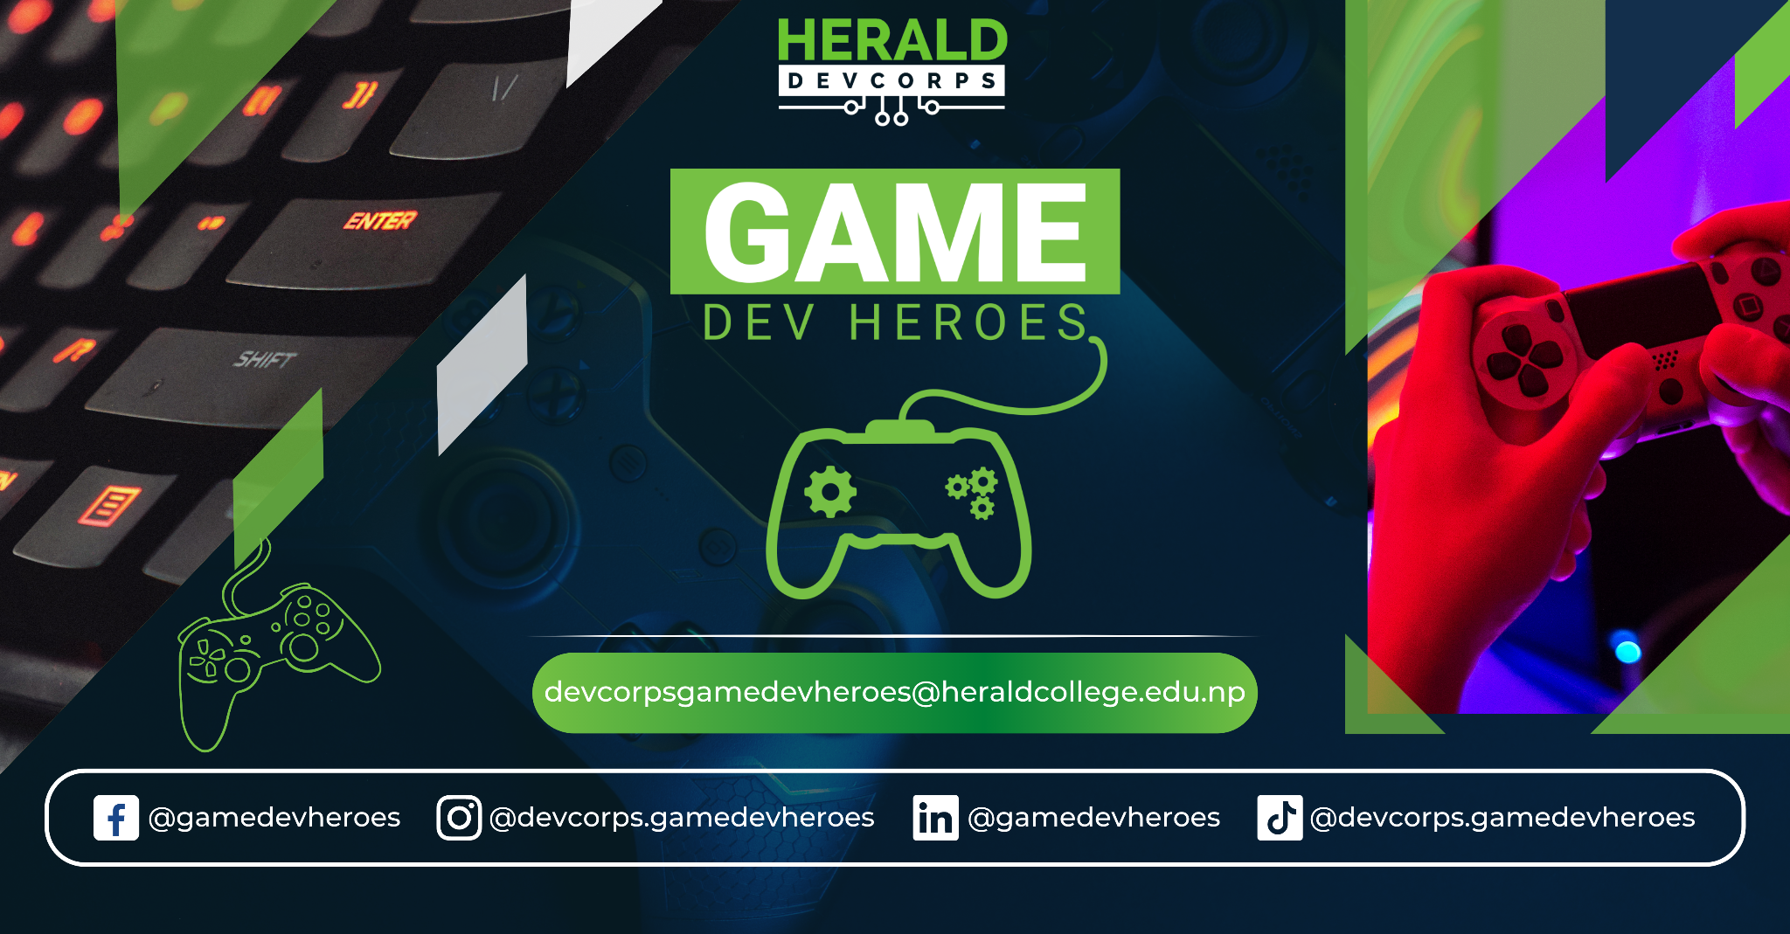

**How does it function?**

**Game Dev Heroes** is a community that operates within the college and focuses on exploring, learning, and teaching about game development to its members and other students. Members of the community come from diverse backgrounds and have varying levels of experience and interests in game development.

To streamline their efforts and maximize productivity, the community is divided into six departments:

* Research & Content Writing
* Design
* Development
* Marketing
* Logistics
* Finance

Each department is responsible for different aspects of game development and employs community members who possess relevant skills and knowledge. All the community leaders are in charge of recruiting new members from their own college's students to maintain a healthy and dynamic community. With this organized approach and collaborative effort, **Game Dev Heroes Community** aims to develop its members' skills and knowledge in game development while also promoting the gaming industry in Nepal.

**Specialization of Game Dev Heroes Community**

**Game Dev Heroes Community** specializes in preparing students for entry-level positions in the video game industry. We focus on utilizing different game engines to develop practical skills in game development.

In addition, the community is designed to provide students with a basic understanding of programming languages such as C# and C++, as well as additional scripting languages like Unreal Script, XML, Lua, Python, and JAVA which are frequently used in game development. By mastering these programming languages, students can learn how to design, develop, and create their own games from scratch.

The specialized training and skills acquired through the Game Dev Heroes Community can help students pursue entry-level positions in the video game industry and kickstart their careers in game development.

**Objectives of our community**

**Game Dev Heroes Community** has several objectives. The first objective is to provide students with the opportunity to learn, explore, and expand their knowledge of game development. By participating in the community's programs and activities, students can gain practical experience in game development and learn how to use different game engines and programming languages.

Another objective is to prepare students for entry-level positions in the game development industry. The community's specialized training and focus on practical skills can help students pursue careers in game development and start their journey in the industry.

Furthermore, the community aims to help students enhance their leadership, communication, public speaking, and presentation skills. These soft skills are crucial in any industry, including game development, and can help students excel in their future careers.

By achieving these objectives, the Game Dev Heroes Community hopes to inspire and support the next generation of game developers in Nepal and contribute to the growth and development of the video game industry in the region.

**Generation of Game Dev Heroes Community**

**Community Members of 2022/023**

**Sneha Bega**

Leader/Marketing Head

**Saurav Adhikari**

Leader/ Design Head

**Samrat Rai**

Leader

**Ranjana Mahato**

Leader/Finance Lead

**Grishma Shrestha**

Leader/Logistics Lead

**Nabin Tako**

Leader/Development Head

**Shreejan Shrestha**

Leader/Research Head

**Nitesh Chaudhary**

Member

**Community Members of 2023/024**

**Saksham Shrestha**

Member

**Pratik Panthi**

Member

**Aaryan Shrestha**

Member

**Prashant Khatri**

Member

**Past Events**

* **Introduction to Game Development**

July 18, 2020 at 11 AM

Webinar on Game Development

Mr. Saurav Bajracharya (Co-founder of Semantic Creation)

Game Dev Heroes hosted a webinar on Introduction to game development, which was led by a senior game developer and co-founder of Semantic Creation, Mr. Saurav Bajracharya. The one-hour webinar aimed to guide the audience through the basic game development process, while also sharing Mr. Bajracharya's experience as a game developer. At the end of the session, Mr. Bajracharya also took the time to clear any doubts or questions that the audience had.

Webinars like these can be incredibly valuable for students and aspiring game developers who are interested in learning more about the industry and the process of game development. By bringing in experienced professionals like Mr. Bajracharya, Game Dev Heroes can provide unique insights and guidance to its members, while also helping to build connections and foster a sense of community among its members.

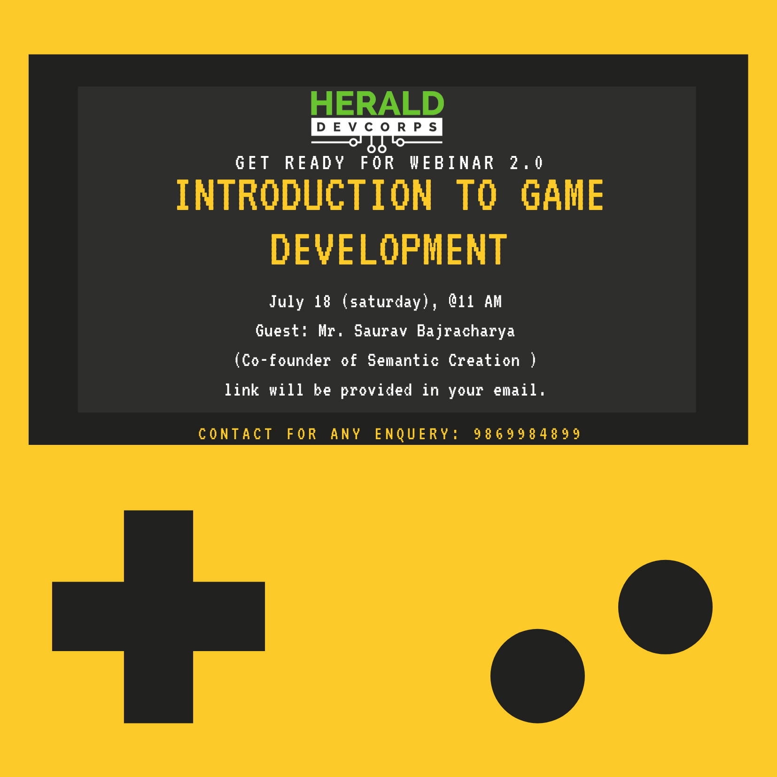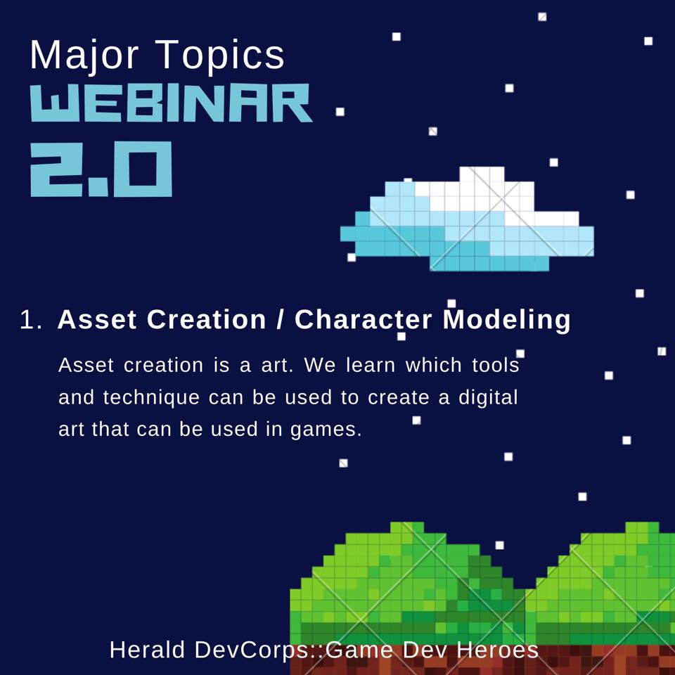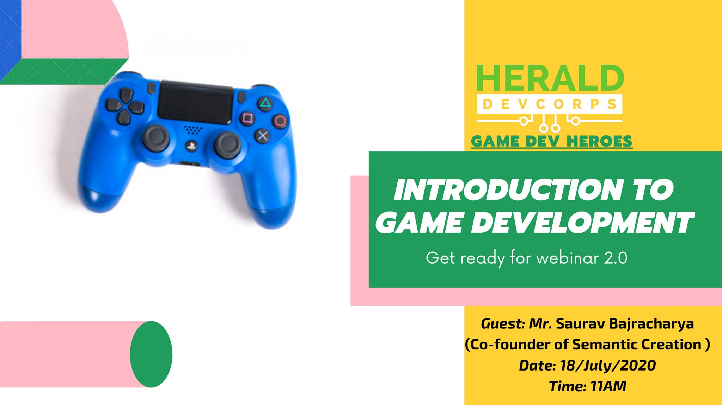

* **UI/UX in game Development**

June 05, 2021 at 10 AM

The Rise and Fall of Games

Mr. Ayush Shakya (Senior UI/UX Engineer)

Game Dev Heroes organized a UI/UX in Game Development session led by Mr. Ayush Shakya, a Senior UI/UX Engineer. This kind of session is incredibly valuable for aspiring game developers who want to learn more about the importance of user interface (UI) and user experience (UX) in game design.

UI/UX design plays a crucial role in making games more engaging, intuitive, and enjoyable for players. By bringing in a senior UI/UX engineer like Mr. Shakya, Game Dev Heroes can provide unique insights into the best practices and techniques for designing effective UI/UX in games. This kind of knowledge can help members of the community to create more polished and engaging games that can stand out in the competitive gaming industry.

Overall, organizing sessions like these is a great way for Game Dev Heroes to provide value to its members, while also helping to build connections and foster a sense of community among its members.

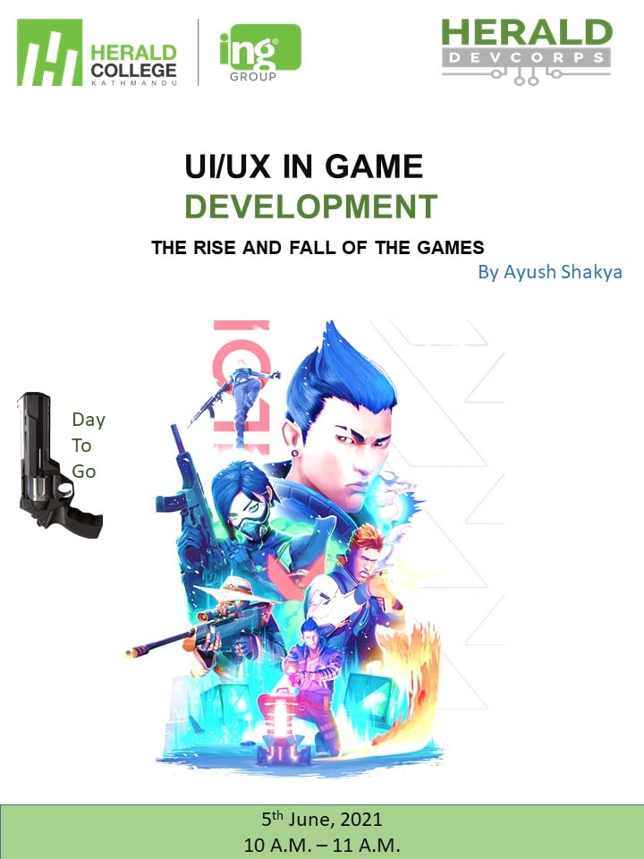

* **Life as a Game Developer in Nepal**

November 08, 2021 at 1 PM

Inside The Life Of Game Developer in Nepal

Mr. Prashant Man Gayak

Game Dev Heroes organized a session featuring Mr. Prashant Man Gayak, who will be sharing his experience of working in the game development industry of Nepal. This kind of session can be incredibly valuable for aspiring game developers who want to learn more about the industry in their own country.

By bringing in a professional like Mr. Gayak, Game Dev Heroes can provide unique insights into the opportunities and challenges of working in the game development industry in Nepal. Members of the community can learn about the kinds of projects that are being developed in Nepal, the skills and experience needed to succeed in the industry, and the potential for growth and innovation in the sector.

Overall, this kind of session can help members of Game Dev Heroes to better understand the industry they are hoping to join, and to gain valuable insights into the experiences of professionals who are already working in the field.

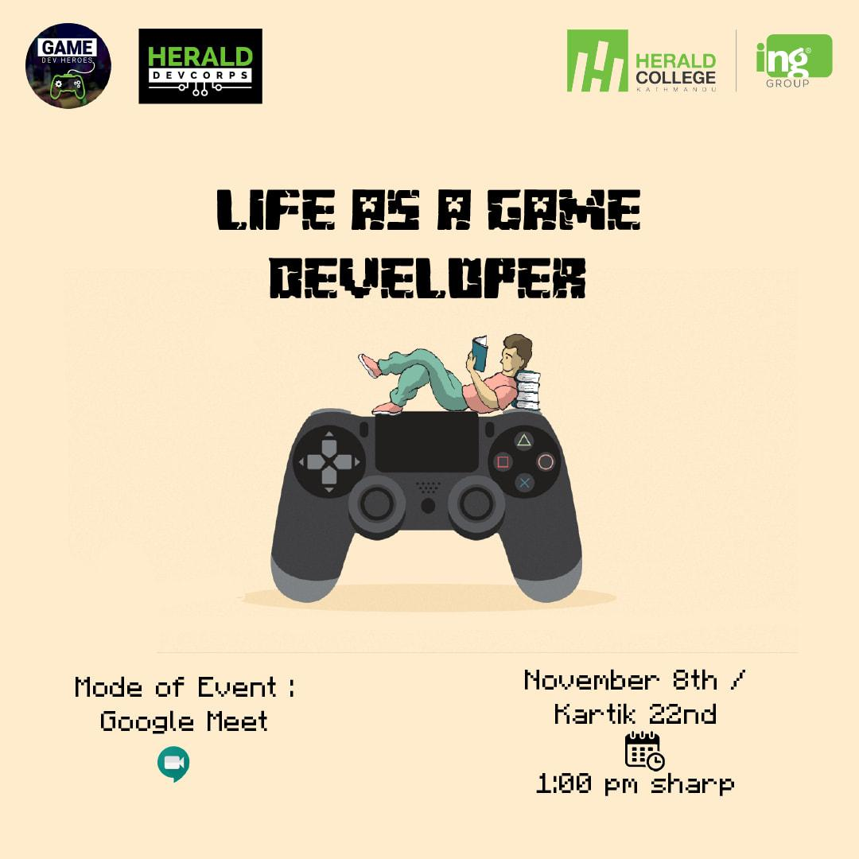

* **FIFA Tournament**

November 17, 2022 at 2 PM

World Cup 2022

Game Dev Heroes Community organized a FIFA tournament to celebrate the FIFA World Cup 2022. This tournament provides an excellent opportunity for Heraldians of all levels to come together and compete in a fun and exciting event.The tournament was initiated by Mr. Saurav Adhikari, who did a great job in organizing and managing the event. The tournament likely involved multiple rounds of matches, with players competing against each other to determine the ultimate champion.

Overall, the FIFA tournament is a great way to bring all the students of the Herald together and promote a sense of fellowship and friendly competition. It also provides an opportunity for students who are passionate about gaming and game development to showcase their skills and abilities in a fun and engaging way.







* **Valorant Tournament**

December 05 - December 09, 2022 at 2 PM

E-Sports in Nepal

Game Dev Heroes Community organized a successful VALORANT tournament at Herald College. The tournament brought together students and staff members from different levels of the college to participate in this exciting event. The competition was fierce, and the players showed their skills and passion for the game.

The matches were held in the college's gaming lab, which was equipped with the latest gaming gear and equipment. The tournament was structured in a way that ensured fair play and equal opportunities for all participants. The tournament lasted for several days, with multiple rounds of elimination, until only the top teams remained. The final match was intense and closely contested, with both teams showing incredible skills and teamwork.

In the end, ‘Team Andhakar’ emerged victorious and was crowned the VALORANT champion of Herald College. The tournament was a huge success, and it provided an opportunity for students and staff members to come together, showcase their skills, and have fun playing the game they love.

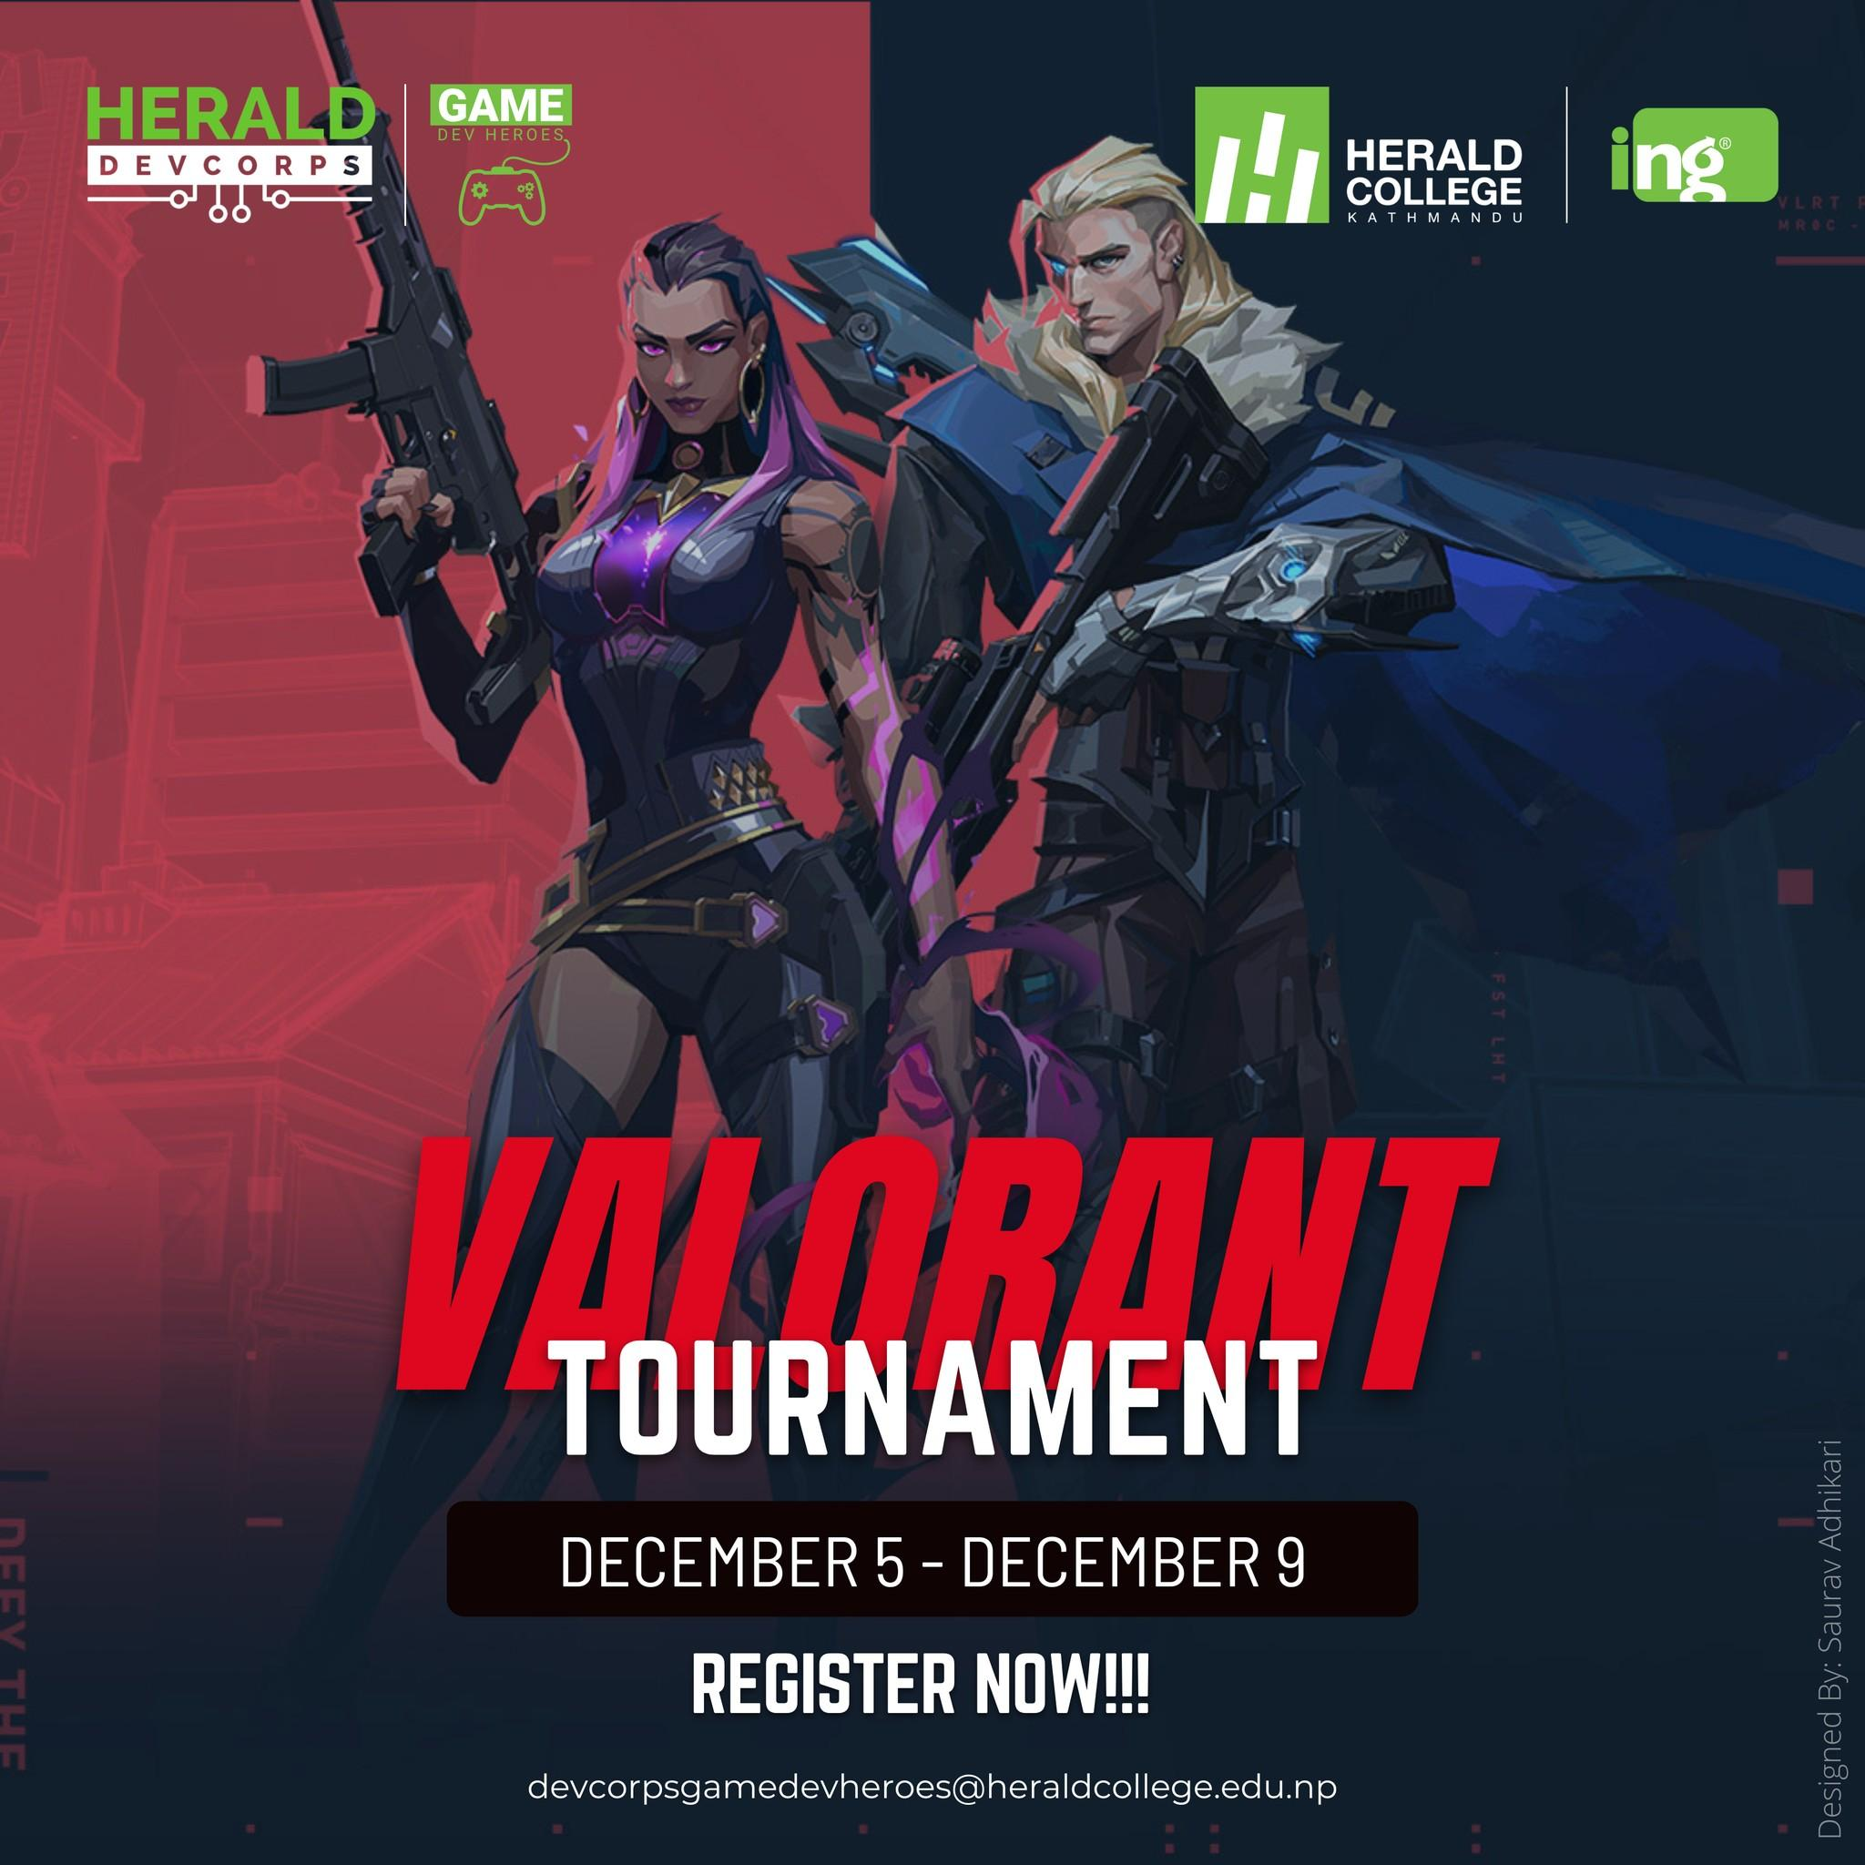

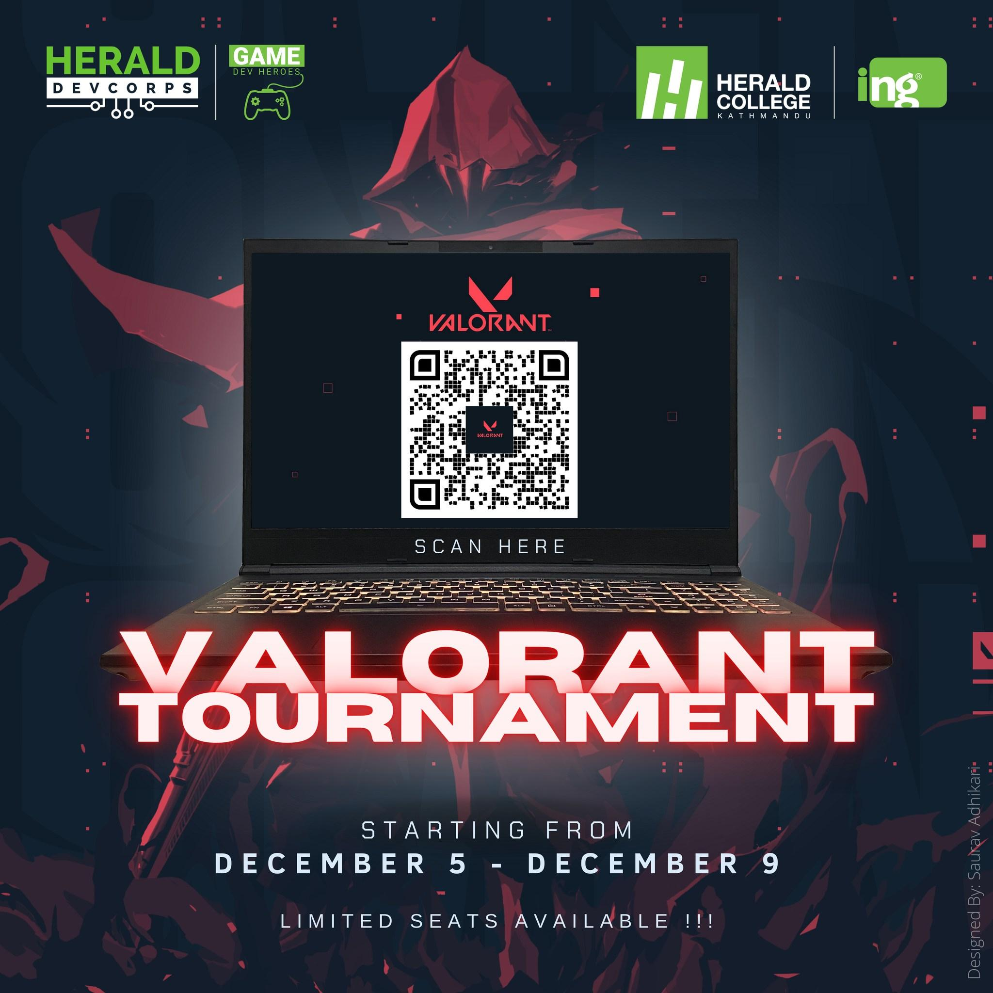

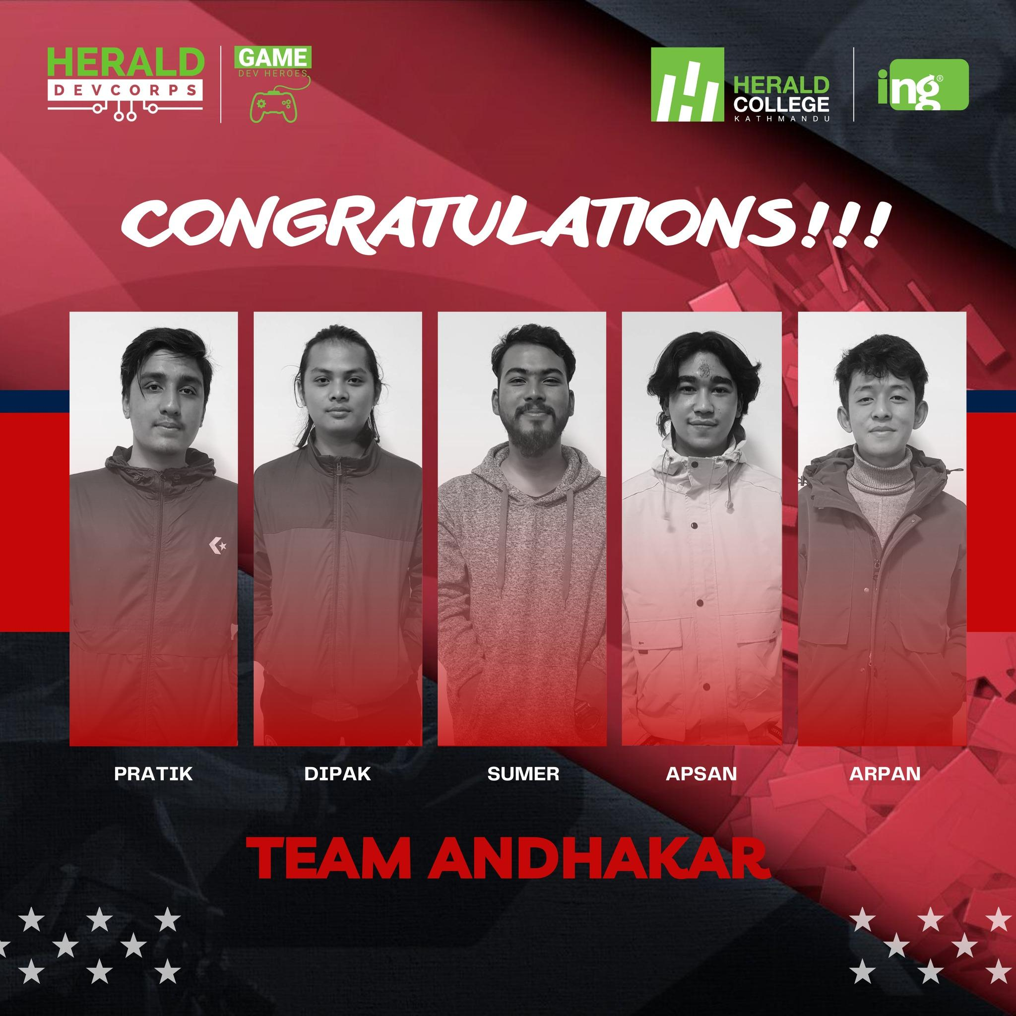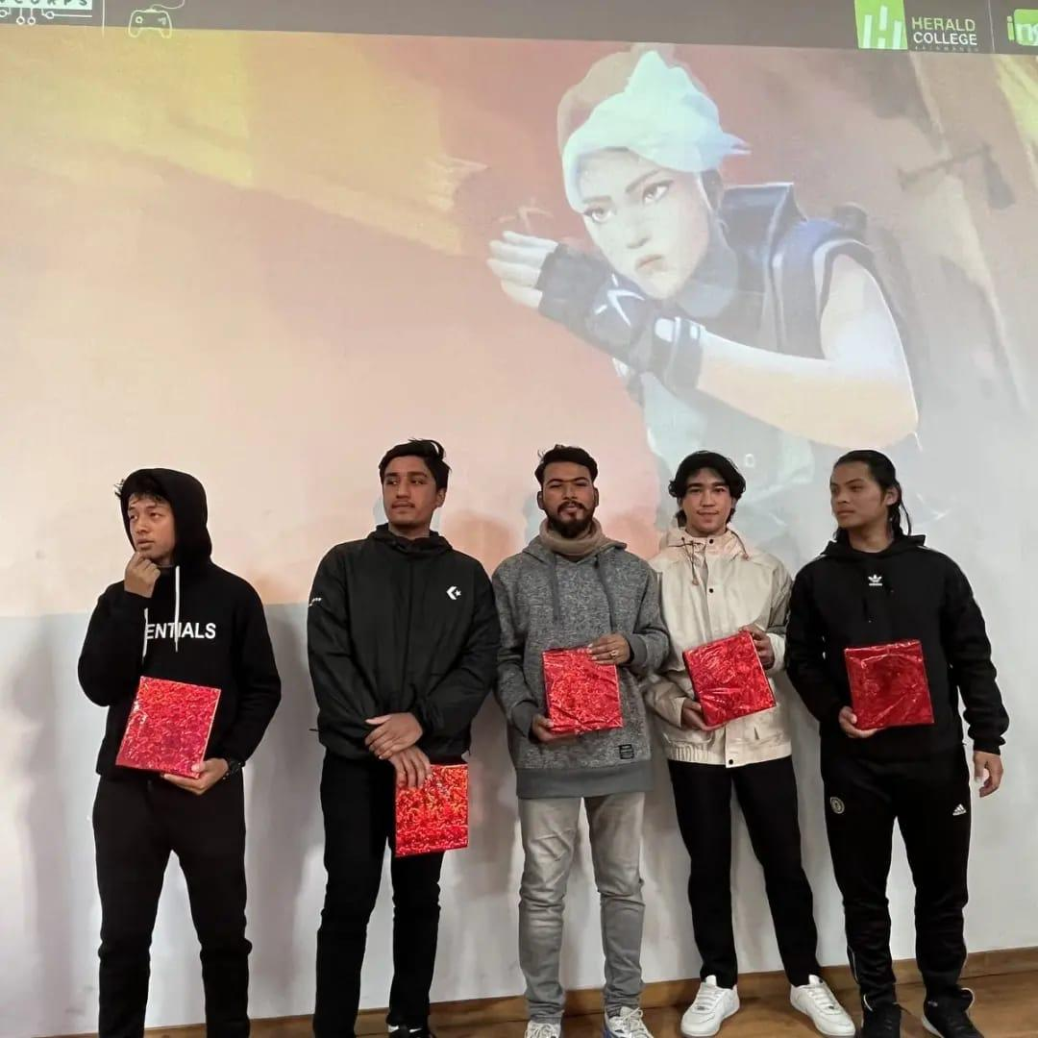

* **UPC Session for new students**

February 07, 2023

Introduction to Game Engines & Game Development

A session about game engines and game development for new UPC early birds was organized by Game Dev Heroes. The event was handled successfully with the help of the community members. During the session, the attendees learned about different game engines used in game development, including Unity and Unreal Engine. The community members also explained the basics of game development, including programming languages, game design, and asset creation. The session was interactive, and the attendees had the opportunity to ask questions and get answers from the experienced community members. Overall, the session was informative and provided a solid foundation for beginners interested in game development.

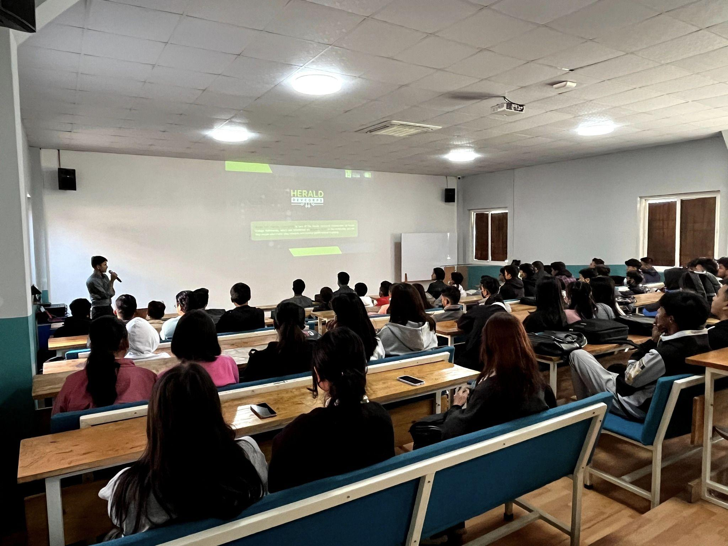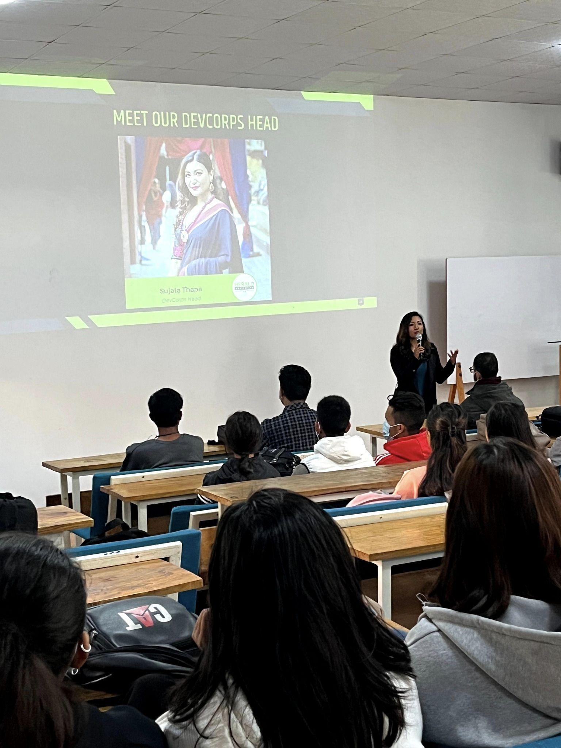

**Weekly Meetings**

Game Dev Heroes Community organizes weekly meetings for its members, providing an opportunity for students to come together and discuss various aspects of game development. The meetings are designed to help members gain a deeper understanding of the different stages involved in game creation, including research, content writing, development, design, finance, logistics, and marketing.

During the meetings, members share their ideas, discuss new game development trends and technologies, and exchange tips on how to improve their skills. In addition, the meetings also provide a platform for members to showcase their work, seek feedback from others, and collaborate on various game development projects.

The meetings are usually conducted in a casual and friendly environment, allowing members to network and build relationships with each other. Overall, the weekly meetings play a crucial role in fostering a sense of community and promoting collaboration among members of Game Dev Heroes.

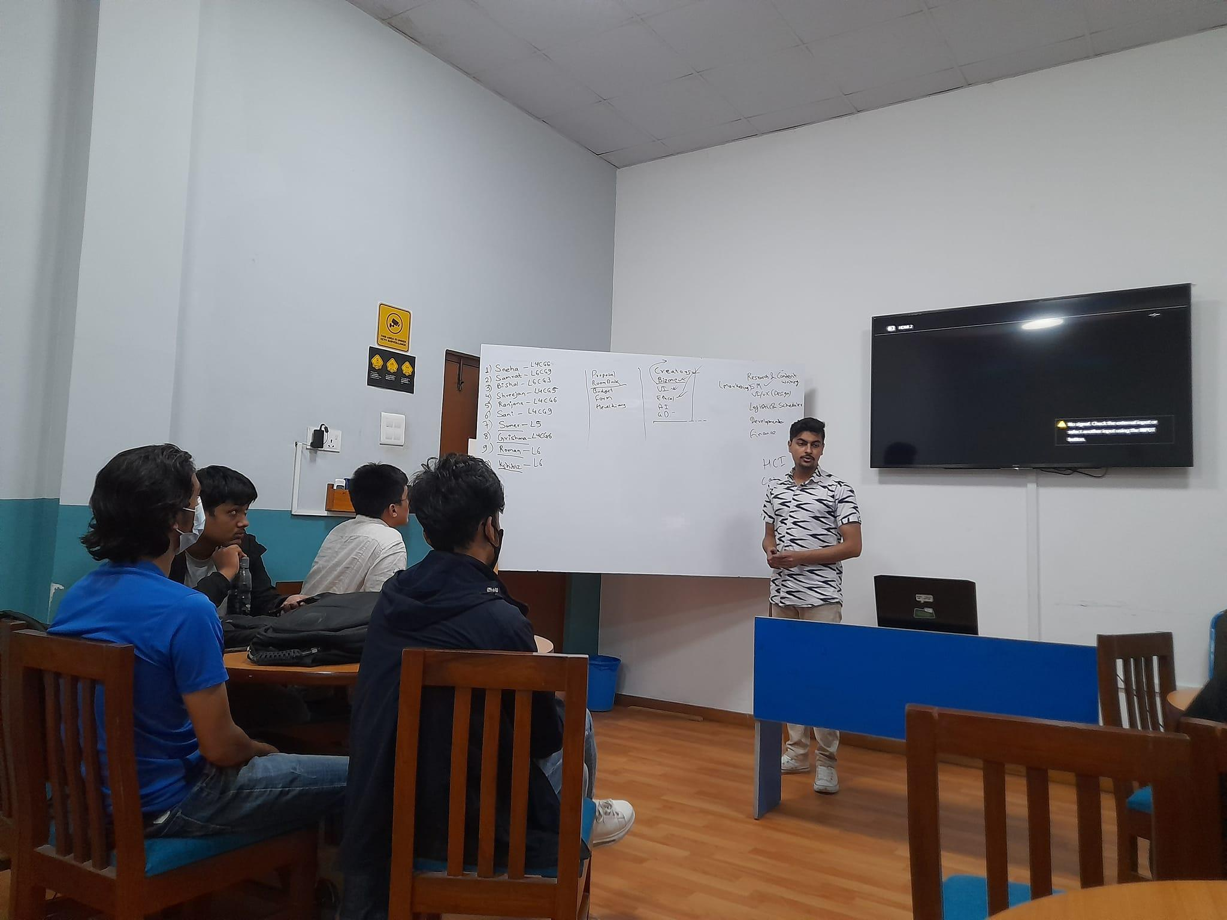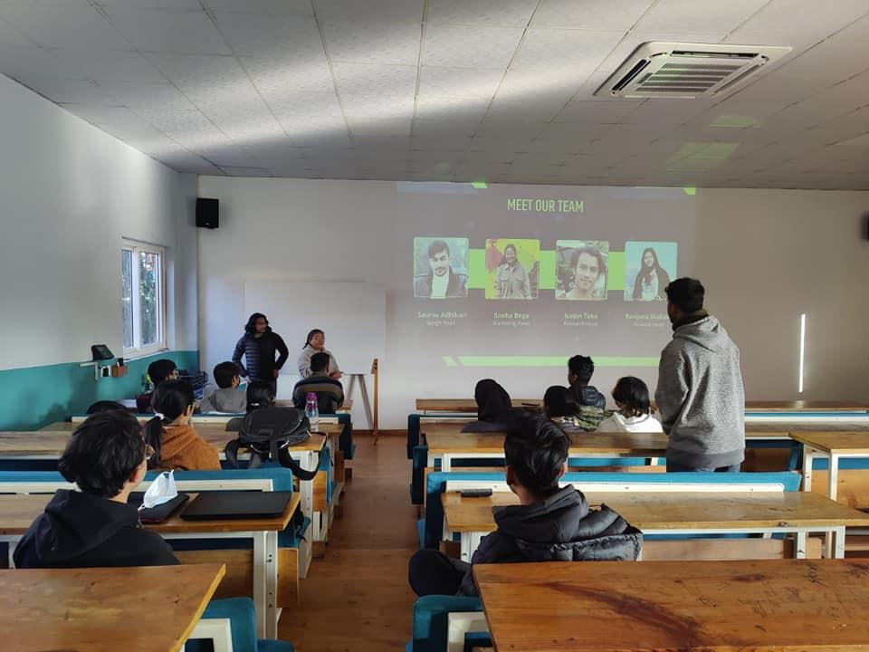

**Herald DevFest 2021**

As part of the Devfest 2021 event, Game Dev Heroes organized a session on "Life as a Game Developer in Nepal" presented by Mr. Prashant Man Gayak, a seasoned game developer with years of experience in the industry.

The session was aimed at providing an insight into the challenges and opportunities faced by game developers in Nepal. Mr. Gayak shared his personal experiences and provided valuable tips and advice for aspiring game developers on how to succeed in this field. He talked about the current state of the gaming industry in Nepal and how it is evolving. He also highlighted the importance of networking and collaboration within the industry. Participants had the opportunity to ask questions and interact with Mr. Gayak, who shared his knowledge and expertise with enthusiasm.

Overall, the session provided a great opportunity for students and budding game developers to gain a deeper understanding of the game development industry in Nepal and learn from someone who has been successful in this field. It was a great addition to Devfest 2021 and an excellent example of the knowledge-sharing and collaborative spirit of the Herald Devcorps community.

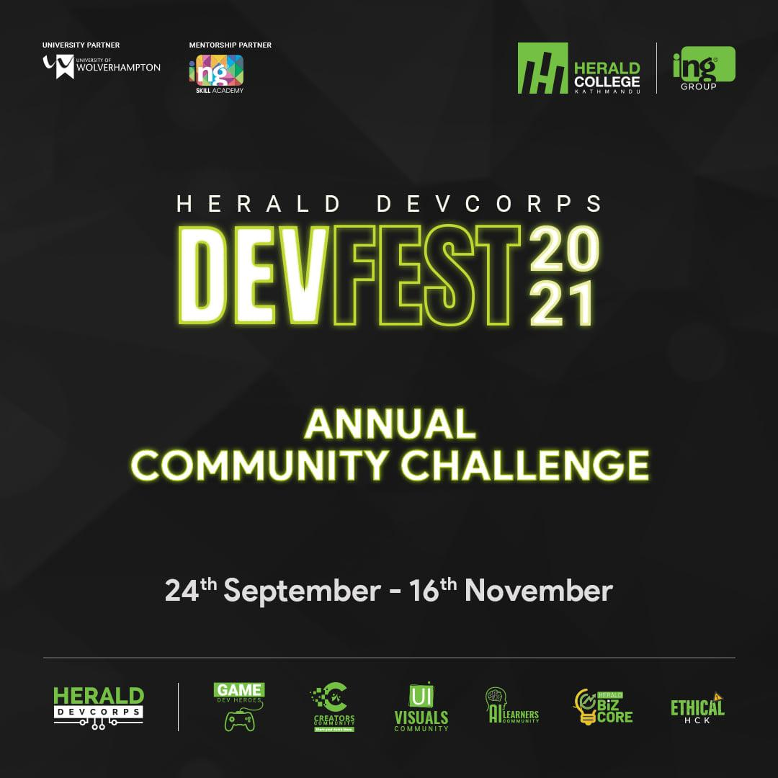

**Herald DevCorps Odyssey 2022**

During the five-day session “Herald Devcorps Odyssey”, Game Dev Heroes members actively participated in all the workshops and seminars alongside members from the other five communities. The event provided an opportunity for participants to learn about a wide range of themes related to graphic design, industrial visits, interpersonal skill development, and digital marketing.

Through these sessions, the members of Game Dev Heroes community had the opportunity to learn and develop soft skills that improve their capacity for teamwork, communication, leadership, and problem-solving. They also had the chance to interact and network with members from other communities, which helped to build cross-functional connections and foster collaboration.

Overall, the event was a great success and provided an excellent platform for members of Game Dev Heroes community to learn and grow alongside their peers from other communities within Herald DevCorps.

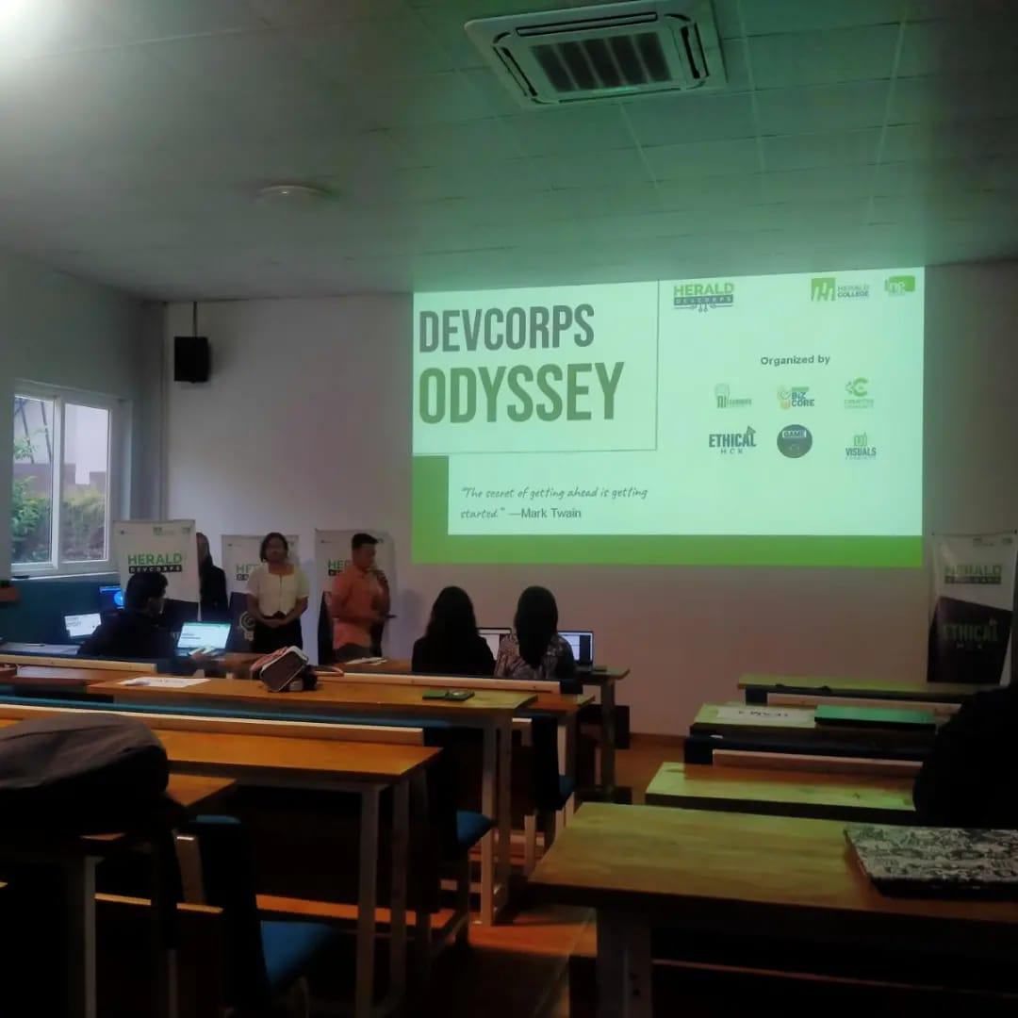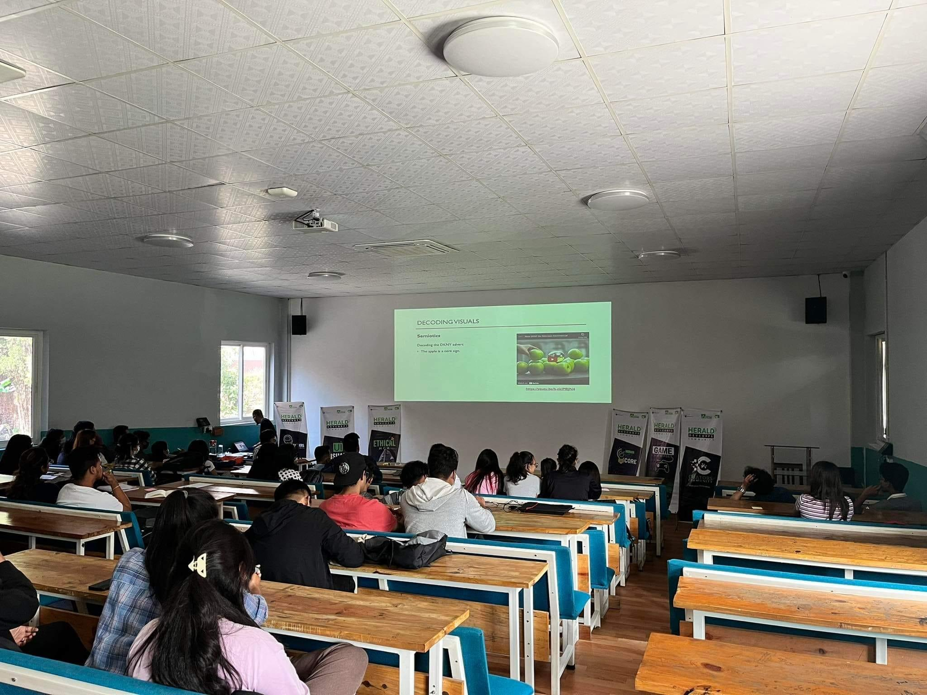

**Why Should People Join Your Community?**

There are several reasons why students should consider joining the Game Dev Heroes Community:

* Learn and Explore: The community provides students with the opportunity to learn and explore the world of game development. Members can gain practical experience in game development by using different game engines and programming languages.
* Networking: Joining the Game Dev Heroes Community allows students to connect with other like-minded individuals who share their passion for gaming and game development. Networking is a great way to make connections and learn from others in the industry.
* Preparation for Entry-Level Positions: The specialized training and practical skills gained through the community can prepare students for entry-level positions in the game development industry.
* Soft Skills Development: The community also focuses on developing important soft skills such as leadership, communication, public speaking, and presentation skills. These skills are transferable and can help students excel in any career.
* Industry Exposure: Being a part of the Game Dev Heroes Community can also provide students with exposure to the gaming industry. Members can learn about the latest trends and technologies in game development, attend events and conferences, and meet industry professionals.

In summary, joining the Game Dev Heroes Community can provide students with a wealth of opportunities to learn, network, and prepare for a career in the game development industry.

**Future Projects**

Game Dev Heroes Community has planned a series of exciting events and sessions for its members in the near future. These include:

* Unity Game Development Workshop - A workshop on Unity game development will be organized by the Game Dev Heroes community. The workshop will cover the basics of game development using Unity, such as creating game mechanics, user interfaces, and game environments.
* Game Design Competition - Game Dev Heroes community will host a game design competition, where members can showcase their creativity and design skills by creating a game concept and presenting it to a panel of judges. The competition aims to promote the development of innovative and entertaining game ideas.
* Industry Guest Speaker Sessions - Game Dev Heroes community will be inviting industry experts to share their knowledge and experience in game development through guest speaker sessions. These sessions will provide valuable insights into the latest trends and developments in the gaming industry.
* Career development sessions: Provide sessions focused on career development in the game development industry, such as resume building, interview skills, and networking strategies.
* Collaborative Game Development - Game Dev Heroes community plans to encourage members to collaborate on game development projects. Members can work in teams to create a game from scratch, starting from concept and design, to development and testing.

These upcoming events and sessions are a great opportunity for Game Dev Heroes members to expand their knowledge and skills in game development and meet other like-minded individuals.